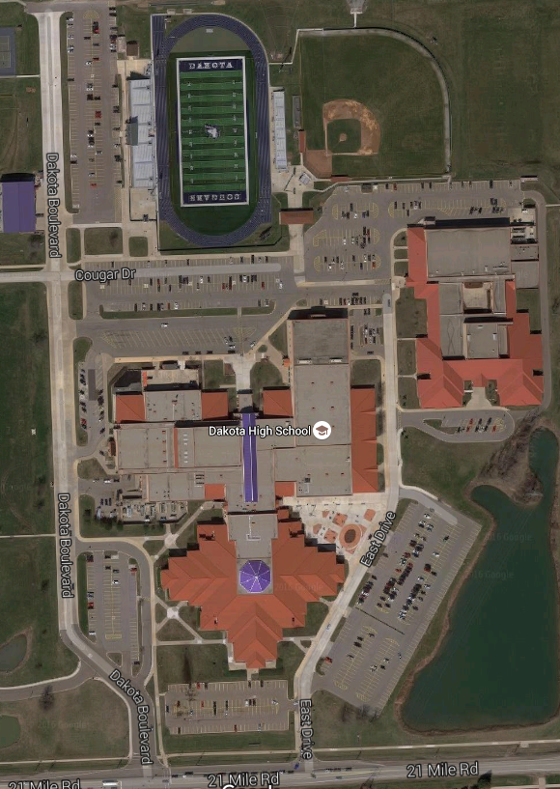

**MAIN ENTRANCE**

Student vehicles parked in staff/visitor lots will be towed at the owner’s expense.

Student vehicles parked illegally (handicapped spaces, fire lane or not in a marked spot) will be ticketed by the Macomb County Sheriff’s Office

**SUGGESTEDENTRANCES**  
YELLOW – 1  
BLUE – 2  
GREEN – 2 or 3  
ORANGE – 3  
PINK – 2 or 3

Students must park in their assigned lot. Students caught parking in the wrong lot (this includes switching permits with another student) may lose their parking permit for the year with no refund.

9th Grade Center

**3**

**1**

**2**

**WEST LOT  
Blue Permits Only**

**BUSSES ONLY**

**STAFF AND GUEST PARKING ONLY**

**CO-OP LOT  
Yellow Permits Only**

**SOUTH LOT  
Purple Permits Only**

**STAFF PARKING ONLY**

**BASEBALL LOT  
Orange Permits Only**

SS

**NORTH LOT  
Green Permits Only**

**STAFF ONLY**

**STADIUM LOT  
  
Pink Permits Only**