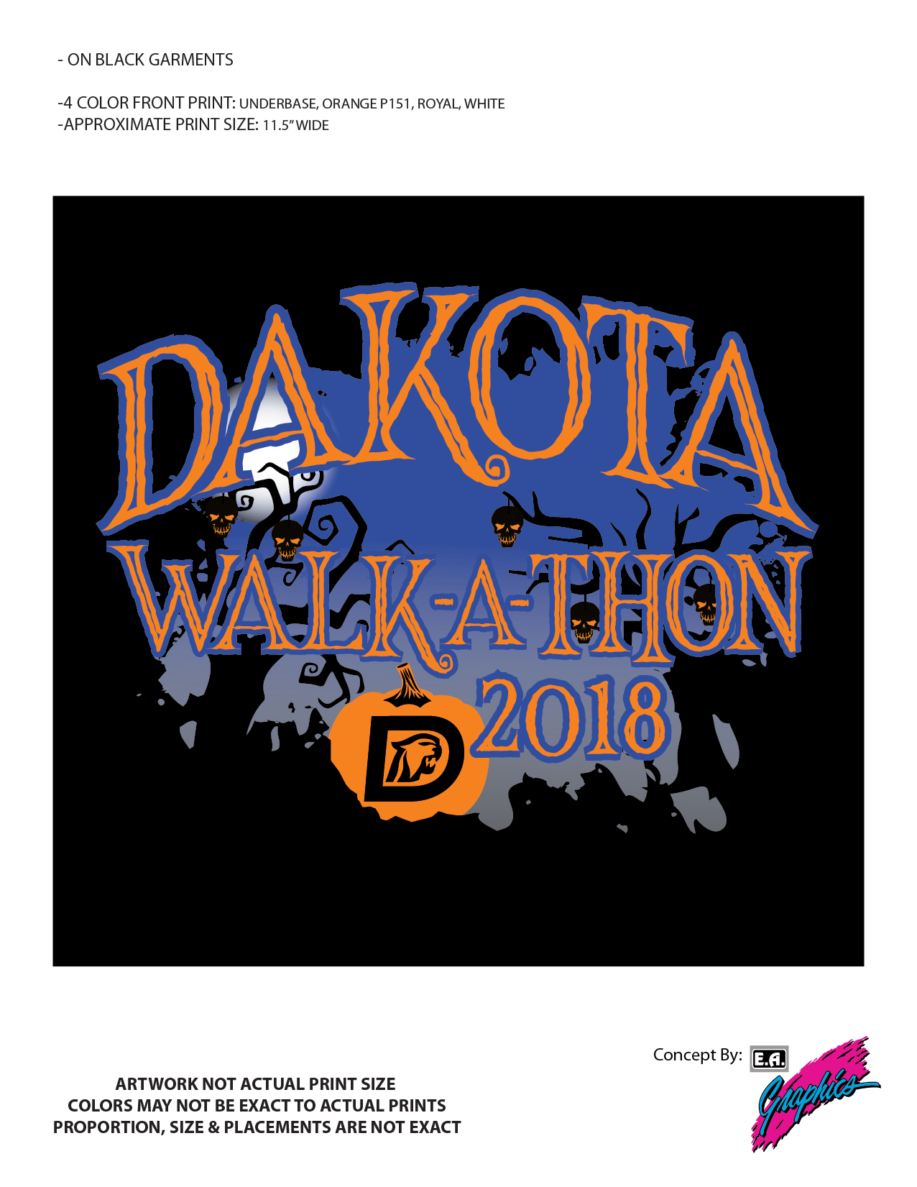
Dakota High School’s Walk-A-Thon is the fundraising event of the year that helps Dakota come together,
have fun, and raise money to benefit students.
Walk date= October 31st!
What will your student get for their donation?
Participation in the walk-a-thon | $5
walk, 5 tickets*, cider & donut | $10
walk, 10 tickets*, cider & donut, LED tumbler cup | $25
walk, 10 tickets*, cider & donut, LED tumbler cup, lunch line fast pass | $50
walk, 10 tickets*, cider & donut, LED tumbler cup, lunch line fast pass, and…  ...1/2 day pass for you AND a friend that includes a pizza lunch and movie w/ popcorn in the auditorium. | $100
walk, 10 tickets*, cider & donut, LED tumbler cup, lunch line fast pass, and…  ...personalized parking spot of your choice for the school year (parking pass sold separately) | $100
*a ticket can be used for games or for a chance to win one of the many prizes donated by local businesses

